**Copy or Add to Achieve**

**Move a File**

**Rename a File**

**Delete File**

**Create Directory**

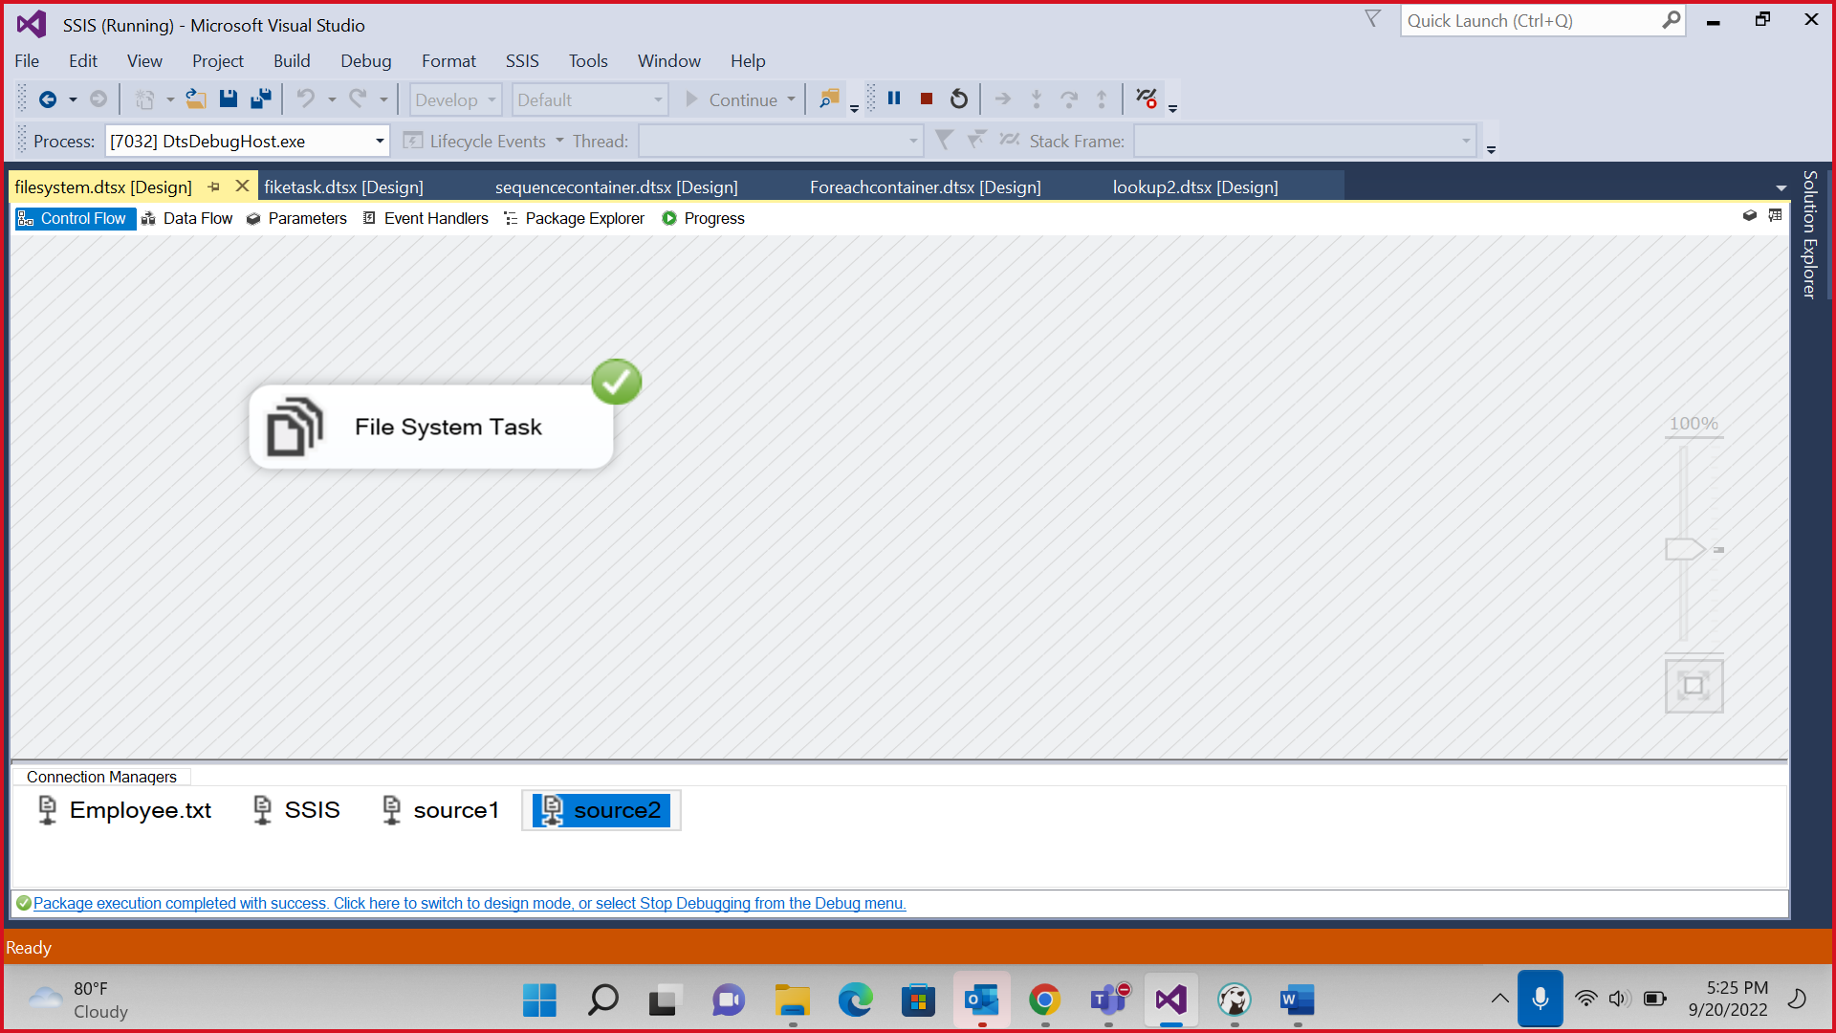

**Copy Directory**

**Move Directory**

**Delete Directory**

